Publicly Created Money and Monetary Reform

A New Finance Initiative

House of Commons Early Day Motion 854

Forum for Stable Currencies

Publicly Created Money and Monetary Reform

A New Finance Initiative

House of Commons Early Day Motion 854

Forum for Stable Currencies

London

© Forum for Stable Currencies 2003

This work may be reproduced, copied and transmitted without the permission of the publishers subject to the following conditions:

- that all extracts and quotations shall be acknowledged

- that if reproduced no part of the work may be altered without the express written permission of the authors

Breach of these conditions shall in turn be a breach of the provisions of the Copyright, Designs and Patent Act 1988.

Published by Forum for Stable Currencies ,
21a Goldhurst Terrace, London NW6 3HB.

Thanks are due to Titus Alexander, Richard Murphy, Molly Conisbee, David Boyle, Pat Conaty, Rafiq Manji, James Robertson, Michael Rowbotham, Sabine McNeill, Donald Martin, Peter Challen, John Courtneidge and Andrew Simms.

About the publisher

The Forum for Stable Currencies promotes monetary and banking reform to Parliamentarians and concerned citizens through regular lecture series and debates held at the House of Lords.

http://www.intraforum.net/money/forum/main.htm

Tel. 020 7328 3701. Email: sabine@globalnet.co.uk

Contents

Summary | 4
Early Day Motion 854 | 4
Purpose | 5
The Third Way | 5
Do banks really create money? | 5
How do banks create money? | 6
Is this credible? | 6
Why do banks do this? | 7
Won’t publicly created money mean inflation? | 7
How will publicly created money cut the cost of financing government spending? | 8
How do you stop banks issuing new money as well? | 9
How much could this save the government? | 9
How could the cost of public investment be halved using publicly created money? | 9
Notes | 10

Summary
This paper explains why the publishers are supporting an Early Day Motion¹ tabled in the House of Commons by David Chaytor MP (Bury North)² entitled “Publicly Created Money and Monetary Reform: A New Finance Initiative”. Co-signatories at the time of tabling on March 10th 2003 are Austin Mitchell MP (Grimsby), Dr. Rudi Vis MP (Finchley & Golders Green), Alan Simpson MP (Nottingham South), Harold Best MP (Leeds – North West), Martin Caton MP (Gower) and John McDonnell MP (Hayes & Harlington).

The EDM suggests that the government investigate the proposals made by the MPs signing the EDM and supported by the publishers of this paper. These proposals suggest that it is possible to fund public services without incurring additional costs of borrowing . The proposals also suggest that this can be done whilst controlling inflationary lending by private banks.

Early Day Motion 854

The full text of the EDM is as follows:

"That this House, concerned at the rising burden of private debt³, public borrowing⁴, student borrowing⁵ and public-private finance initiatives⁶;

- notes that the proportion of publicly created money⁷ in circulation has fallen from 20% of the money supply in 1964 to 3% today⁸;

- believes that increasing the proportion of publicly created money in issue may provide a new means of financing public investment;

- further notes that it is suggested that the use of publicly created money can cut the cost of public investment by at least one half of what it would otherwise be by eliminating the need to pay interest⁹;

- accepts that such a policy can be adopted without any impact on inflation if suitable regulatory changes¹⁰ are made;

and therefore urges the Treasury¹¹ and Treasury Select Committee¹² to commission independent reviews on procedures for increasing the proportion of publicly created money in the economy and on the benefits of so doing and report them to this House¹³."

The remainder of this paper explores the issues that this EDM raises, and explains the thinking behind it.

Purpose

The EDM suggests the investigation of a new way of raising money for use by government. It does so with the specific intent of pointing out a way that avoids the interest and financing costs that are incurred if the government either borrows money or finances projects through the Private Finance Initiative or Public Private Partnerships. As such it proposes investigation of a “third way” for raising money to pay for public services. The other ways are taxation and borrowing.

The Third Way

The EDM suggests that this “third way” is for the government to create more of the money used in the UK economy. It is commonly assumed that the government creates all money. This is not true. In fact the only money that is at present created by the government is notes and coin, and that is only the case in England and Wales. In Scotland and Northern Ireland all paper currency is issued by commercial banks. It is important to note this. It shows that there is choice to be had.

To put matters in perspective, according to the Bank of England there were £29.6 billion (i.e. thousand million) worth of notes and coin in issue in the UK in November 2002. But since most transactions do not use notes and coin but do instead involve payments from one bank or building society account to another, these have also to be considered ‘money’ for all practical purposes, and they are. In November 2002 the total value of such deposits exceeded £1,000 billion (or one trillion) for the first time, reaching £1,001 billion in that month.

It can be seen by comparing the figure for notes and coin and the figure for all cash available in bank accounts that the government creates 2.95% of all money. Commercial banks create the rest.

Do banks really create money?

The simple answer is “yes”, yet most people read these statistics and still do not believe that banks actually create money. They like to think that banks simply take in what is commonly thought of as money (i.e. notes and coin) from the public and then pay it out again. By doing so they want to agree with the eminent economist John Kenneth Galbraith, who said “the process by which banks create money is so simple that the mind is repelled. Where something so important is involved a deeper mystery seems only decent”¹⁴. It is essential to understand just how this “repulsive” process works to understand what this EDM is proposing.

How do banks create money?

In its simplest form the process does start with a person paying some notes and coin into a bank. For convenience let us assume they pay in £100.

As a matter of fact banks know that most people do not draw out in cash most of the money they have in a bank account. They do instead write cheques, or pay by direct debit, charge card and so on. So, if the bank has received £100 of cash they know that there is very little chance that the person who paid it in will ask for it all back. In practice they need to keep in cash just that part that the person is likely to ask for again. This is called the “reserve ratio”.

If a bank estimates that its reserve ratio is 10% this means that they have to keep 10% of all deposits made in cash, as this is likely to be asked for by the person whose account it is in. The rest of the cash they can use themselves, and they do. In fact, they can safely loan £90 of the cash received to another customer. As a result the money supply increases by £90. The original depositor still has a deposit of £100, but the borrower now has £90 as well.

That is not the end of the story because the £90 that has been lent will itself almost certainly be deposited straight into a bank account. The lending process will then start again: the bank will hold back 10% of the £90 (or £9), and loan £81 to another customer, and so on. With each deposit and loan, more money is created and enters the money supply. It is, however, important to note that the process is not infinite as 10% of every deposit has to be kept, if that is the reserve ratio.

In practice, if the reserve ratio is 10%, for every £100 of cash deposited in a bank £1,000 can be lent by the bank. And if the reserve ratio is 2.95%, for every £100 deposited, banks can create £3,390 of lending, even though they never had that much money to start with.

Is this credible?

A lot of people find this hard to accept. They just cannot believe that a bank can lend something they have not got. And the banks certainly do not advertise that this is what they do. But it is actually quite possible, because double entry bookkeeping allows it to happen.

W hen a bank lends money it opens two accounts for that person. One is a loan account. The other is a current account. To lend money, all a bank has to do is make an entry of, say, £1,000 in the current account, thus creating cash the person can spend. This is what people think of as a “credit” balance. The other side of the accounting entry is in the loan account. This will be marked as being overdrawn by £1,000, and that will show that the money is owed back to the bank. This is usually thought of as a “debit” balance. The trick of using two accounts has meant that cash has been created out of nothing, and the bank’s books still balance.
The fact that there never was cash, and that the balances have been created out of nothing, is proved by adding them up. A positive £1,000 and a negative £1,000 when added together come to zero. And yet by using this trick banks have created money, and have created for themselves the right to charge interest.

Why do banks do this?

There are simple reasons why banks do this:

- it generates them a profit. There is an income to be made simply from the process of making money. Robertson and Huber¹⁵ estimate that UK banks make approximately £48 billion a year from the creation of money.

- There is profit to be made from arranging loans. It is common for a bank to charge at least 1% of a sum borrowed just to arrange the loan. The more loans a bank can offer, whether or not it has cash available to make them, the more it can make.

- It increases bank’s profit on lending. If you can lend ten or more times the amount initially deposited, you can charge ten or more times the interest you could if you just lent the original deposit. That remains true even if you have to pay out interest each time the money is re-deposited as banks always charge more on loans than they pay on deposits. That is why banks want as low a reserve ratio as possible.

This system has existed since before 1700 when the Bank of England was created. The concern at the practice was such that Section 9 of the Bank Charter Act of 1844 required that any profit arising to the Bank of England (then a private bank) from creating currency had to be paid to the government. The Section in question was repealed by 1891. The current EDM suggests it is time to restore the right of the public to profit from the creation of currency, as it was more than 150 years ago.

Won’t publicly created money mean inflation?

There is a widespread fear of governments “printing money”. It is believed that this causes inflation. This risk does exist if there is uncontrolled creation of money, but that is exactly what we have at the moment. There is currently no effective regulatory mechanism to stop banks creating new money. In practice, public control of money creation is likely to reduce substantially this risk. This is, of course, the complete reverse of the commonly held view, but statistics and facts support it.

Between September 2001 and September 2002, for example, the total money supply including all bank and building society deposits as measured by the Bank of England increased from £936.3 billion to £989.5 billion. That is an increase of £52.2 billion, or 5.7% in a year.

Inflation in this period was 1.7% (as measured by the retail prices index) and the increase in Gross Domestic Product (based on HM Treasury data) was 5.2%. The money supply in this period grew by more than was needed to finance growth by either measure.

It suits banks that growth (as measured by money) trails in the wake of the increase in the money supply, as is shown to be happening by these statistics. The reason for this is that the more the money economy grows the more money they have to create cash. And the more cash they create out of nothing the more profit they make. The current system of cash creation by banks is, therefore, inherently inflationary but the government has to constrain its own activities to counterbalance this trend rather than any bank.

This is again shown by publicly published statistics. During the same twelve-months period to September 2002 the amount of publicly issued cash and notes in the economy grew by just 1.9%, and, in fact fell throughout 2002. The government was much more prudent in the financial management of its element within the money supply than the commercial banks over this period. The idea that governments have an incentive to print money is wrong, as is shown by this graph showing the growth of M4 (bank created money) and M0 (government created money) over a thirty year period.

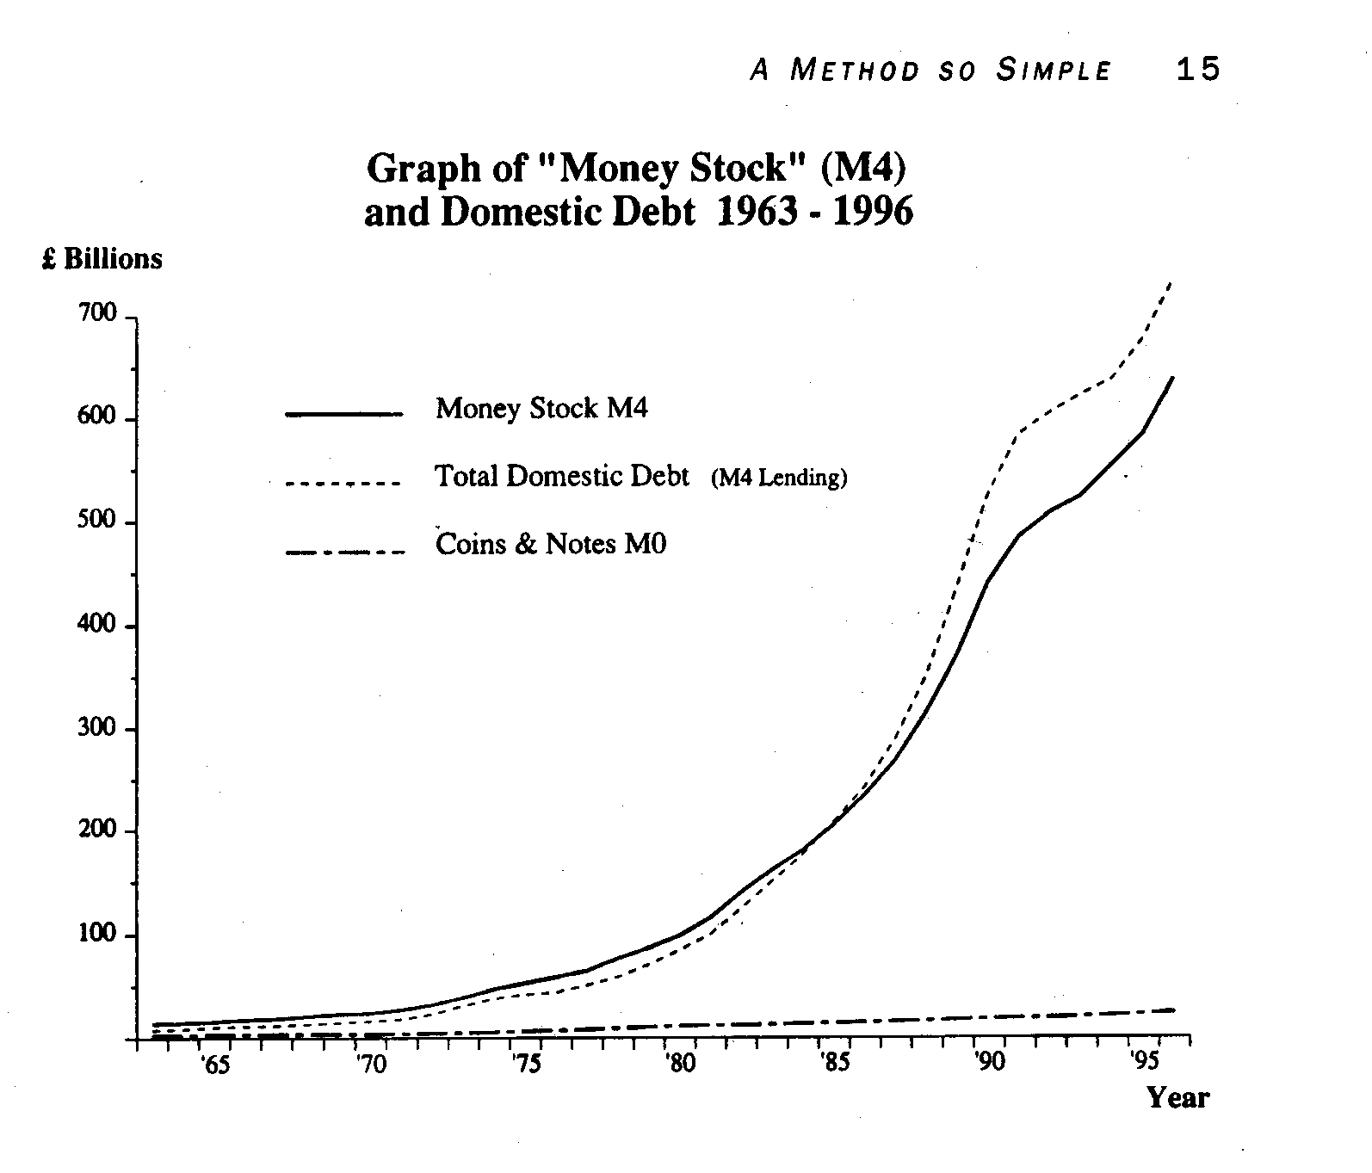

This graph makes clear that government has been a better manager of its part of the money supply than the banking sector. Even so, it might be unwise wholly to trust any one government with such a powerful economic tool as publicly created money. This could be avoided by independent oversight of the issue of publicly created money, either by the Bank of England or by a new independent authority. Any Commission set up to investigate these matters would need to study the options.

How will publicly created money cut the cost of financing government spending?

The process is as simple as that by which commercial banks now create money.
What would happen is that the Bank of England would lend money to the government to the extent that it was agreed that new money was needed in the economy (and no more). That new money would be spent by the government from a current account it maintained with the Bank of England. It would of course owe it back to the Bank of England. The twist in this case is that the loan would not carry interest and might not require repayment. In that way the benefit of issuing new money would belong to the government, and not commercial banks, since the Bank of England is government owned.

How do you stop banks issuing new money as well?

This is quite simple. You make it illegal for them to do so! This will not affect any bank accounts now in existence, or the well being of any person or their entitlement to any asset they now have. All it will require is a law that says that banks must recognise that the money held by their customers in current accounts belongs to those customers, and not the bank. That will mean that banks cannot then use that cash to create new loans, as current accounts would no longer be part of a bank’s reserve ratio. As such banks will not be able to, literally, make money from customers’ current accounts.

This will not, however mean that cash for loans will not be available. Publicly created money saved with banks (and a great deal of cash is saved in this way) will be re-lent (without the creation of new money) by the banks to those customers who want to borrow it. This is, of course, how most people think banks work now. As such the proposal made is instinctively acceptable.

How much could this save the government?

Robertson and Huber¹⁵ suggest that this reform might save the government £48 billion a year. Other opinions are no doubt available based on different bases of calculation. What is clear is that the amounts involved are substantial. To put the matter in context:

- total income tax received by the government in 2001/02 was £110 billion¹⁶

- PFI capital spending in the year to June 2002 was £2.62 billion¹⁷

It is clear that the amount of money created by banks, which could be created for public benefit, is substantial when compared with this data.

Why could the cost of public investment be halved using publicly created money?

This is the result of a simple calculation. Many public investments are in long term assets such as schools and hospitals. The borrowing that finances them is equally long term, often over 25 years (which is also a typical length of a PFI project).
Even a very basic calculation of the interest paid at 4% on a loan over 25 years shows that 100% of the cost of the asset must be paid in interest – and this is before allowing for compounding. So, if no interest is paid the cost of a project has to be halved. If interest is effectively paid at 16% (as has been suggested to be common on PFI projects) then paying for an asset on an interest free basis using publicly created money would mean that the public cost of the asset falls to no more than 20% if the cost of interest is paid. Again, compounding would actually increase this ratio.

The economic benefits of investigating this proposal are compelling.

Notes
- An Early Day Motion (or EDM) is the term used to describe notices of motions given by Members of Parliament that are not generally expected to be debated by the House of Commons. Effectively, the tabling of an EDM is a device to draw attention to an issue, and to elicit support for it by the means of inviting other Members to add their signatures to the motion. Members may also table amendments to existing motions.

- David Chaytor Labour MP:

- Born 03.08.49, Bury.
- Married. Three children.
- BA and MPhil, London University. Post Graduate Certificate of Education, Leeds University.
- Before entering Parliament worked as Head of Department of Continuing Education, Manchester College of Arts and Technology.
- MP for Bury North since 1997. Chairman of All-Party Group for Further Education. Member of Environmental Audit Select Committee (to 2001). Calderdale councillor (1982 - 1997).
- Member of T&G and Greenpeace.
- Main leisure pursuits are walking, cycling, and reading.

- Private debt has, according to the Bank of England, grown at the rate of 13.5% over the year to October 2002. This is part of a continuing trend of growth in borrowing being in excess of income growth in the UK. http://www.bankofengland.co.uk/mfsd/li/030103/lendind.pdf

- Public sector net debt did, according to HM Treasury data published in November 2002 fall between 1996/97 and 2001/02 by £38 billion but is forecast to increase between 2001/02 and 2006/07 by £97 billion. http://www.hm-treasury.gov.uk/media//54E68/040303PDB.XLS published by the Office of National Statistics for HM Treasury.

- Proposals made in January 2003 suggest the average student will see their student debt on graduation increase by at least £6,000 per annum as a result of increase tuition fees proposed for introduction if Labour are re-elected to a third term in office.

- PFI schemes were worth £3.7 billion in 2001/02 but are proposed to be worth ten times that sum in the foreseeable future (source: HM Treasury and data published at the time of the Labour Party conference 2002 and to coincide with the pre Budget statement November 2002).

- It is commonly assumed that the government creates all money. This is not true. The reasons are explained in the text. Definitions of money used in this paper are included in the text.

- Support calculations that show how such data is computed are in the main text.

- Publicly created money does at present consist of notes and coin. No interest is paid to anyone who holds notes and coin, and as such the principle that publicly created money is interest free is well established.

- The necessary changes are described in the text.

- The Treasury is the Government department responsible for economic management and is headed by the Chancellor of the Exchequer.

- The Treasury Select Committee is a committee of backbench MPs in the House of Commons that scrutinises the work of the Treasury and undertakes critical analysis of it. It is entitled to commission its own research on matters that it believes will further its work.

- The New Economics Foundation has a track record in undertaking such research and was named “Think Tank of the Year” by Prospect magazine in September 2002.

- “Money: Whence it came, where it went” J K Galbraith. 1975.

- “Creating New Money” by James Robertson and Joseph Huber, New Economics Foundation 2000

- HM Treasury Public Finances spreadsheet published November 2002 on HM Treasury web site

- Information extracted from data published by the Office of Government Commerce on PFI deals signed to 31 October 2002 available at http://pfi.ogc.gov.uk/statsView.asp?id=708 on 7 February 2003

